For the following requests, pack your answers into the zip file Assignment1_AccountName.zip, then handle to the evaluator via email ([XYZ@fsoft.com.vn](mailto:XYZ@fsoft.com.vn))

Barem: Q1-30%, Q2.1-40%, Q2.2-30%

## Question 1

Consider the following relations for a database that keeps track of student enrollment in courses and the books adopted for each course (Primary Key is mark post-fix with #):

STUDENT(SSN#, Name, Major, Bdate)

COURSE(Course#, Cname, Dept)

ENROLL(SSN, Course#, Quarter, Grade)

BOOK_ADOPTION(Course#, Quarter, Book_ISBN)

TEXT(Book_ISBN#, Book_Title, Publisher, Author)

Draw a relational schema diagram specifying the foreign keys for this schema.

## Question 2 <<Option>>

Given the Invoice table with following initial structure (Primary Key is mark post-fix with #)

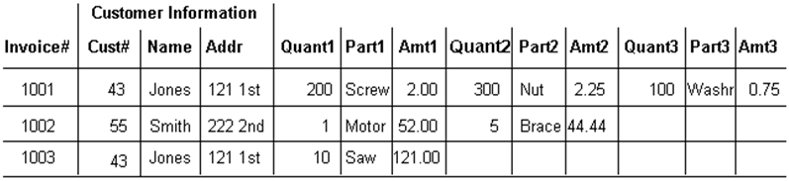

Please:

1. Normalize that table structure to the first, second and third normalization forms
2. Draw relational schema diagram for the tables defined in the third normalization form above